=====================================================================================
Nama: ahmad rafli firman rosyadi
Email : ahmadrapli70@gmail.com
No : 081334185032
Link linkedin : https://www.linkedin.com/in/ahmad-rafli-firman-rosyadi-384377145/
=====================================================================================

Donwload nodeexporter
https://github.com/prometheus/node_exporter/releases/
1. unzip file download dengan
tar xvf node_exporter-0.18.1.linux-amd64.tar.gz
2. masuk ke dir node_exporter
cd node_exporter-0.18.1.linux-amd64/
3. buatkan grup node exporter
sudo groupadd --system node_exporter
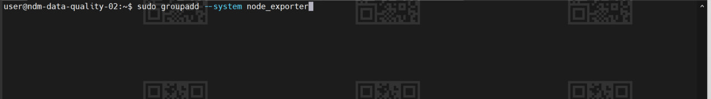
4. buatkan user node exporter
sudo useradd --system -s /sbin/nologin -g node_exporter node_exporter
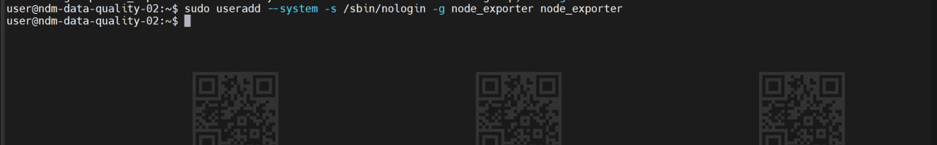
5. memindahkan binary file node exporter ke /usr/local/bin/
sudo cp node_exporter /usr/local/bin/
6. kita cek apakah sudah pindah ke /uss/local/bin/
cd /usr/local/bin
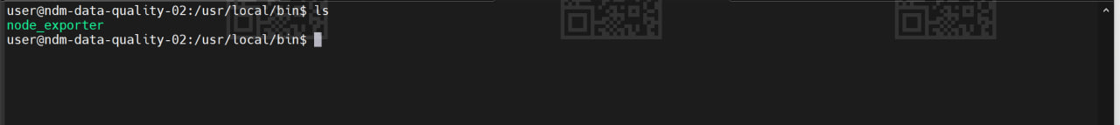
7. membuat folder dalam etc
sudo mkdir /etc/node_exporter
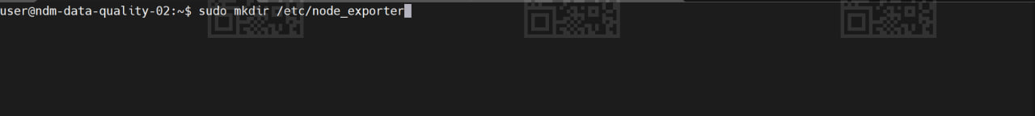
8. membuat folder penyimpanan node exporter
sudo mkdir /var/lib/node_exporter
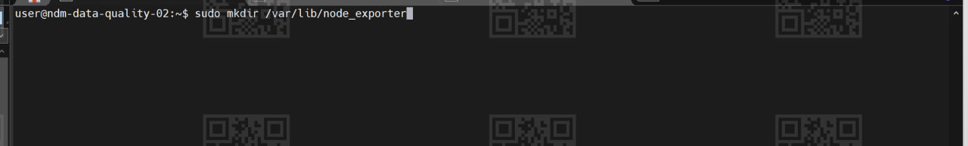
9. ganti owner node exporter
sudo chown -R node_exporter:node_exporter /var/lib/node_exporter/
10. cek owner node exporter
ls -l /var/lib
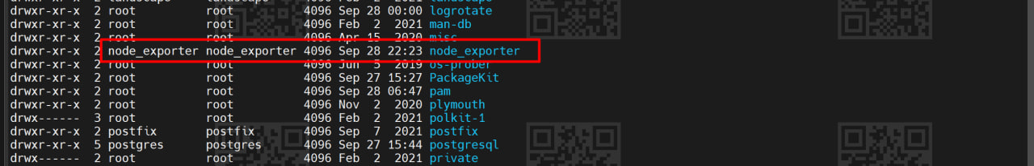
11. membuat service daemon
sudo nano /etc/systemd/system/node-exporter.service
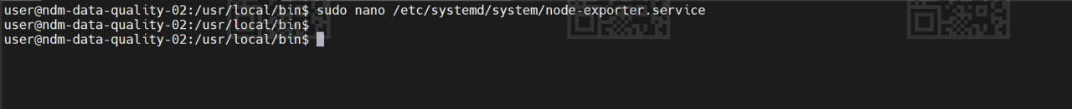
12. setting service dengan isi berikut
[Unit]
Description=Node Exporter
Wants=network-online.target
After=network-online.target

[Service]
User=node_exporter
Group=node_exporter
Type=simple
ExecStart=/usr/local/bin/node_exporter
Restart=always
RestartSec=3

[Install]
WantedBy=multi-user.target
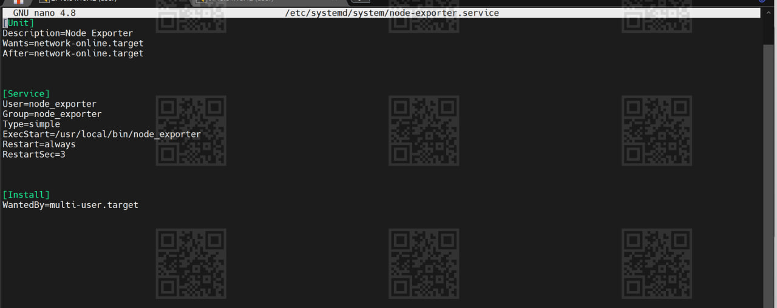
13. reload system
sudo systemctl daemon-reload
14. cek status node exporter
sudo systemctl status node-exporter.service (di sini masih belum aktif)
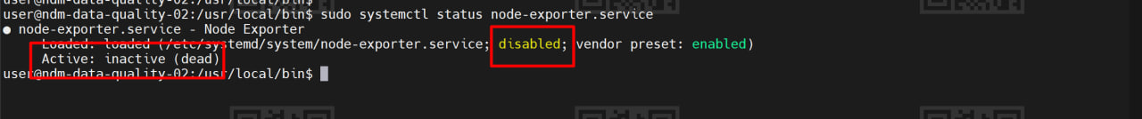
15. aktifkan node exporter
sudo systemctl enable --now node-exporter.service
16. cek status node exporter lagi
sudo systemctl status node-exporter.service
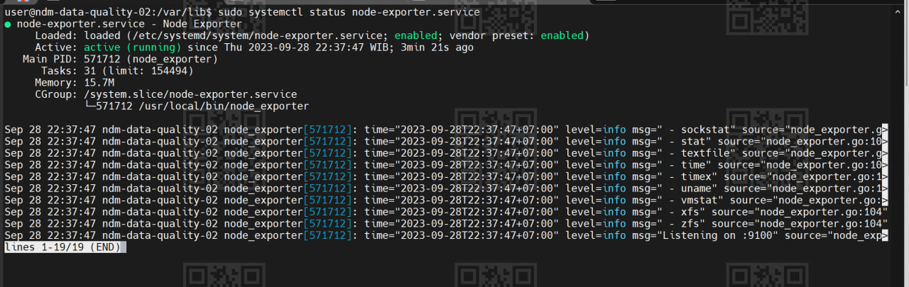
17. cek metrik di browser dengan port :9100
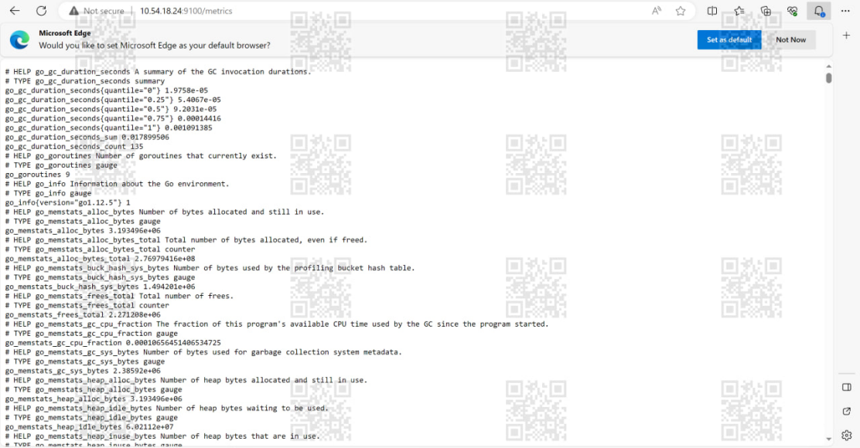
18 . edit prometheus yml di 147 docker
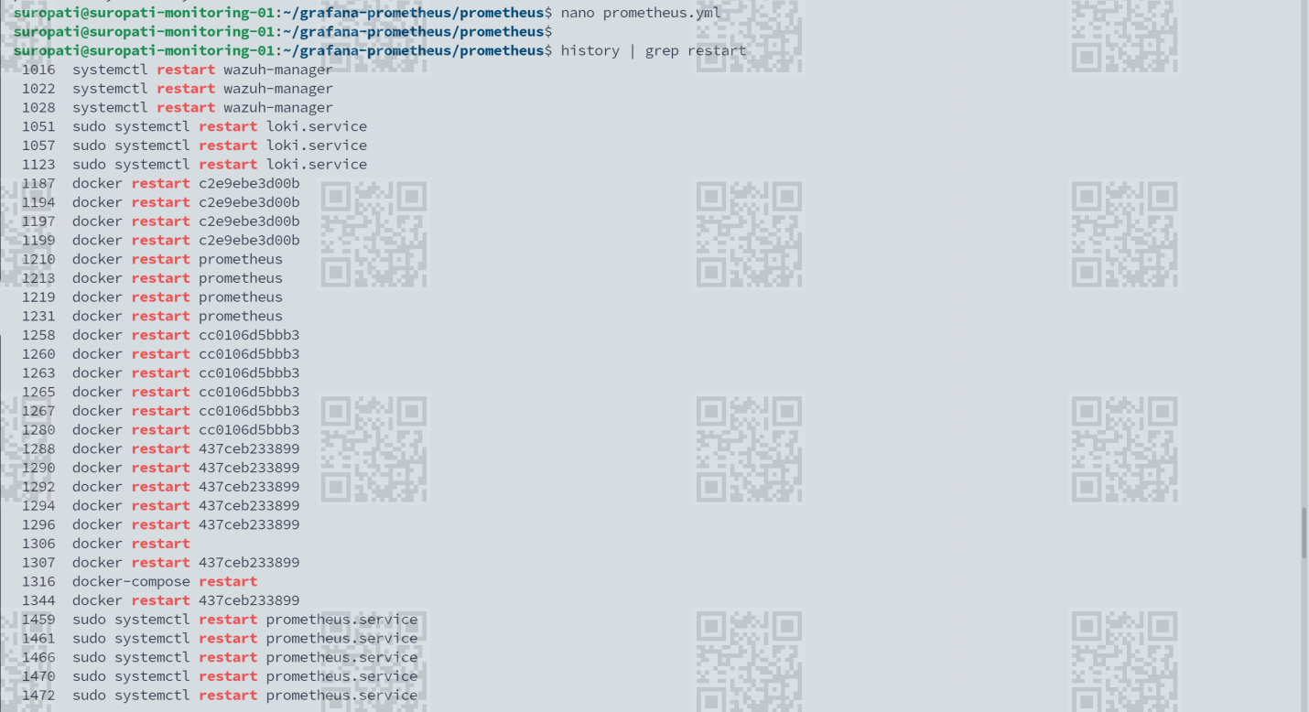
Docker restart prometheus
